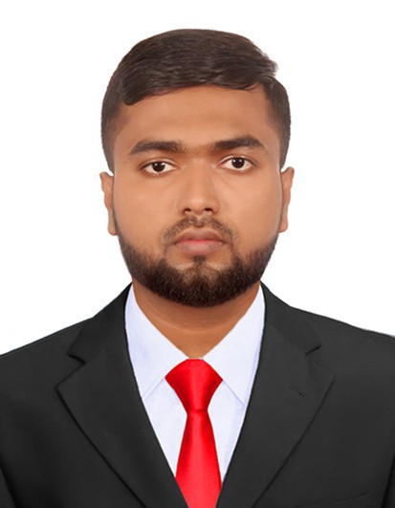
Mohamed Shihab Aaqil
 | ammsaaqil1998@gmail.com
linkedin.com/in/shihab-aaqil-abdul-majeed-mohamed-351114216 |  |  | github.com/AMMSAaqil

 515 D, Hospital Road, Sainthamaruthu-07, Postal code: 32280   076 6035257


Objective
I am a fast learner, hard-working, and self-motivated full-stack developer with expertise in MERN stack development, Flutter, Spring Boot, Golang gRPC microservices, and software engineering. My goal is to contribute to innovative projects by leveraging my technical skills and knowledge of emerging technologies to drive business growth and operational efficiency.

Education
Kingston University (UK) Holmwood House, Grove Crescent, Kingston upon Thames BSc (Hons) in Computer Science in Software Engineering (Top UP) [ Upper Second Class] 2024 - 2025
Institute of Technology, University of Moratuwa Moratuwa, Sri Lanka National Diploma in Technology in Information Technology (Higher National Diploma in Engineering) 2019 - 2023
KM/Zahira College Kalmunai Kalmunai, Sri Lanka
GCE Advanced Level (Physical Science) 2018
Grades: Physics: C, Chemistry: S, Combined Maths: C
KM/Zahira College Kalmunai Kalmunai, Sri Lanka
GCE Ordinary Level 2014
Grades: 5A, 2B, 1C, 1S

Professional Experience
CypsoLabs (PVT) LTD Colombo, Sri Lanka (Remote)
Trainee Software Engineer (Full Stack Development) Nov 2024 - May 2025
- Developed and integrated full-stack features using React, Flutter, Spring Boot, Golang (gRPC), and Next.js.
- Implemented RESTful APIs and microservices with Spring Boot and gRPC.
- Designed UI screens using Flutter and React based on Figma designs.
- Practiced advanced filtering and real-time data fetching in Next.js with TypeScript.
- Contributed to backend services and tested APIs with Postman.
- Participated in daily virtual meetings and version-controlled tasks via GitHub.
Onibots (PVT) LTD Colombo, Sri Lanka (Remote)
Intern Software Engineer (Full Stack Development) Jun 2023 - Jan 2024
- Developed and maintained responsive web applications using the MERN stack.
- Implemented front-end features using ReactJS, Next.js, and Tailwind CSS.
- Designed RESTful APIs with Node.js and Express.js.
- Analyzed business requirements and translated them into technical features.
- Enhanced performance and UX through testing and debugging.
Institute of Technology, University of Moratuwa Moratuwa, Sri Lanka
Institution of Incorporated Engineers, Sri Lanka (IIESL) Colombo 03, Sri Lanka
Business Analyst (Professional Development Guide) 2023 - Present
- Conducted market research and data analysis to support business strategy.
- Facilitated communication between stakeholders and technical teams.
- Documented processes and recommended IT-based improvements.

Technical Skills

Languages: JavaScript, TypeScript, Java, Python, C++, C#
Web and Mobile Development: React, Next.js, Flutter, React Native Backend Development: Node.js, Express.js, Spring Boot, Golang (gRPC), .NET Databases: MongoDB, PostgreSQL, MySQL
Tools: Git, Postman, Figma, Docker, GitHub Actions
Platforms: Deta Micros, Firebase, Render
Business Analysis: Power BI, Excel, SAP, SQL, Process Mapping
Projects E-commerce Advanced Filtering System (Individual)
- Built using ReactJS with real-time dynamic filtering and state handling.
- Enhanced product discoverability with custom filter logic.
LMS Quiz Management System (Team Project)
- Developed using Next.js (frontend) and Spring Boot (backend).
- Collaborated via GitHub with modular TypeScript codebase.
Trading Helping System (Group Project)
- Implemented a crypto signal system with Next.js and Deta Micros.
- Integrated real-time market APIs and microservice architecture.

Certifications and Courses

SLIIT Professional Web Development Programme Introduction to Business Analysis - Online Course
Spring Boot, Flutter, React Native, TypeScript - YouTube/Online Training

Awards and Achievements
National Mathematics Olympiad Competition 2014
Kalmunai Educational Zone Maths Quiz Competition 2013

Clubs and Memberships

IEEE Computer Society, University of Moratuwa Member
SEDS MORA B20 Member
Institution of Incorporated Engineers, Sri Lanka (IIESL) Student Member
Gavel Club of ITUM, ITUM Computer Society Member

References

Dr. (Mrs.) K Galappaththi

Head of Division, Information Technology, Institute of Technology, University of Moratuwa

kgalappaththi@itum.mrt.ac.lk
Ms. Das Ruwanmini
Lecturer, Division of Information Technology, Institute of Technology, University of Moratuwa

ruwanminis@itum.mrt.ac.lk

0714434530

0778558303

